12.You are a professional robber planning to rob houses along a street. Each house has a
certain amount of money stashed. All houses at this place are arranged in a circle. That
means the first house is the neighbor of the last one. Meanwhile, adjacent houses have security systems connected, and it will automatically contact the police if two adjacent
houses were broken into on the same night.
Examples:
(i) Input : nums = [2, 3, 2]
Output : The maximum money you can rob without alerting the
police is 3(robbing house 1).
(ii) Input : nums = [1, 2, 3, 1]
Output : The maximum money you can rob without alerting the
police is 4 (robbing house 1 and house 3).

PYTHON CODE:
def rob_linear(nums):
prev1 = 0
prev2 = 0

for money in nums:
temp = max(prev1, prev2 + money)
prev2 = prev1
prev1 = temp

return prev1

def rob(nums):
if len(nums) == 1:
return nums[0]

return max(rob_linear(nums[:-1]), rob_linear(nums[1:]))

n = int(input("Enter number of houses: "))

nums = []

print("Enter money in each house:")
for i in range(n):
nums.append(int(input()))

print("Maximum money that can be robbed:", rob(nums))

Sample Output 1

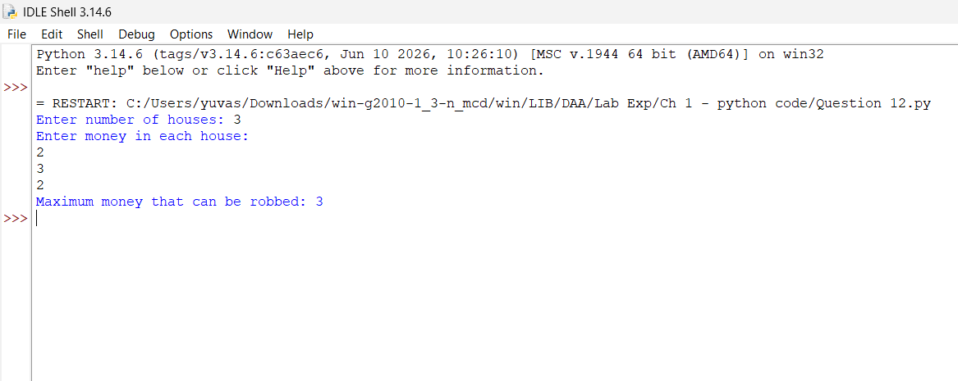

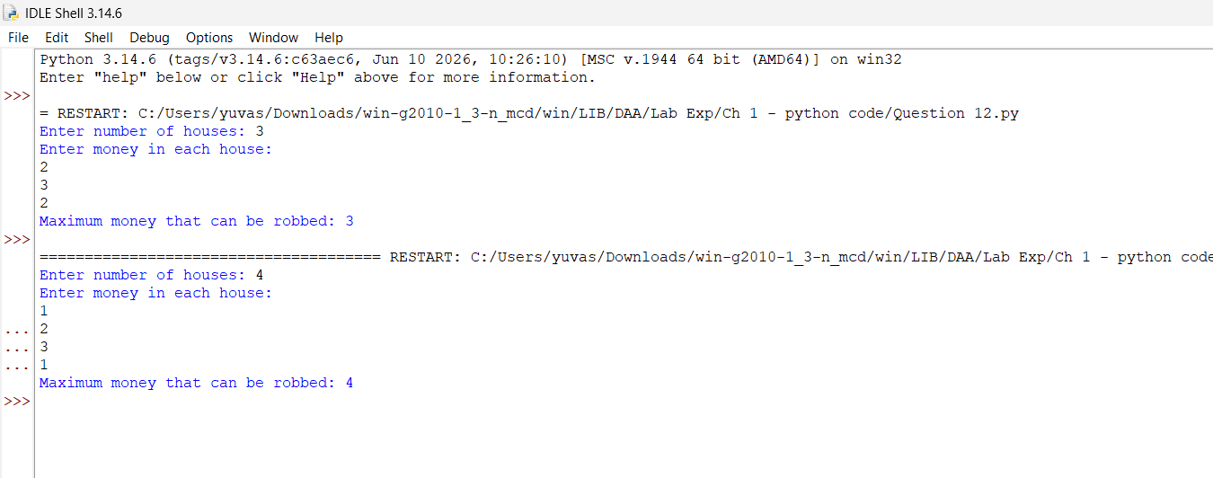
Sample Output 2

